Social Media MOD(Moderator) Daily routine

OJT (On the Job Training)

1. Main Roles
MOD types | Freelancers(Expert) | Internal employee
1. Role | - Likes (Heart, Likes, Laughing)  - Replies  - Comments  - Following  - Retweet  - event moderating | - Likes (Heart, Likes, Laughing)  - Replies  - Comments  - Following  - Retweet  - event moderating
2. Time | 15 hrs / day | 15-30 mins / day
3. Agent | Elizabeth (2024 1Q) | Imperial Asset (Snova)
4. Audit | Daily Morning (GMT + 2) | Daily (GMT + 4)
 | Please report about mod daily MOD tasks to report group chat such as [Telegram : MOD group chat internally] https://t.me/+a2KkBKWT20JmNzk1. And Auditors should detect who didn’t do mod job in the morning everyday morning (It's daily routine every morning in 15 mins)

2. Definition of MOD(MODerator)
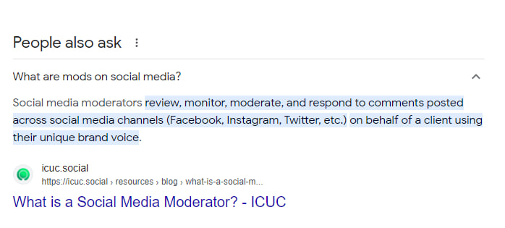
What are mods on social media?
Social media moderators review, monitor, moderate, and respond to comments posted across social media channels (Facebook, Instagram, Twitter, Wordpres and all etc.) on behalf of a client using their unique brand voice. The abbreviation “mod” stands for “moderator,” representing their responsibilities.

[Task ownership] related with MOD task

- Likes (Heart, Likes, Laughing)
- Replies
- Comments
- Following
- Retweet
- event moderating

