OJT: How to Charge the Invoice to Clients
The purpose of this OJT is to ensure that the accounting team can effectively create and send invoices to clients, covering various fees such as server fees, team fees, marketing fees, and management fees.
Scope:
- Identifying the clients to be invoiced.
- Determining the correct amount to be invoiced.
- Creating the invoice with the correct details.
- Sending the invoice to the respective clients.
Steps:
Step 1: Identify the Clients and Fees
- Refer to the provided client list and fee details.
- Example list:
  - Gbrick: 1300 USDT - Client Contact
  - Somi server fee: 890 USDT - Client Contact
  - Somi team fee: 6000 USDT - Client Contact
  - Flickrz: 7000 USDT
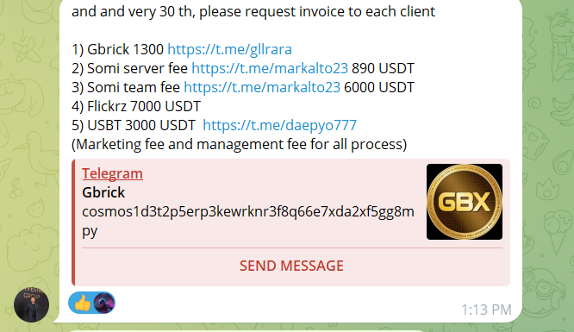
  - USBT: 3000 USDT - Client Contact

Step 2: Prepare the Invoice
- Use a standard invoice template that includes the following details:
  - Client name
  - Description of the service/fee
  - Amount in USDT
  - Invoice date
  - Due date
  - Contact information for queries
Sample Invoice:
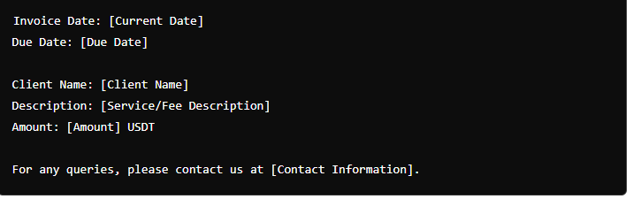

Example:

Message for USBT

Subject: July Server Fee Invoice Request

Dear,

I hope this message finds you well.

As we approach the end of June, I am writing to request the server fee invoice for this month. Kindly send the invoice for the amount of 3000 USDT at your earliest convenience. Your prompt attention to this matter would be greatly appreciated.

Here are the details for your reference:
- Client Name: USBT
- Amount: 3000 USDT
- Due Date: July 30th
- Notes: Marketing fee and management fee for all process

Please let me know if there are any additional details or information needed from my side.
Thank you for your cooperation and timely assistance.

Best regards,
---------------------------------------
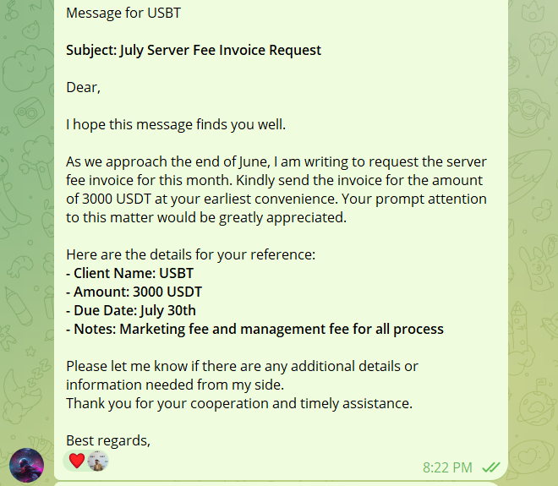
INVOICE SHEET LINK - https://docs.google.com/spreadsheets/d/1Vi3yuWvfXBB7JHNqNGY85t5BP9iSs216RQlMwDVJU7w/edit?gid=0#gid=0
INVOICE CONTENT LINK - https://docs.google.com/document/d/1L0zN7pwtPi-XaQ5IEoIQfXHPEnbqrhNkAZfdBZQsteI/edit

