OJT Plan: Creating a Payoneer Account and Requesting Payment

Objective: Equip employees with the knowledge and skills to efficiently create a Payoneer account and request payments.

Training Overview:
This training will cover the step-by-step process of setting up a Payoneer account and the procedure to request payments from employers.
Step-by-Step Training Guide:

Creating a Payoneer Account:

- Step 1: Visit the Payoneer website and select Register.'
- Step 2: Choose the account type (individual or company) and fill in the required personal details or company information. In your case most probably It will be a Freelancer on Online Professional
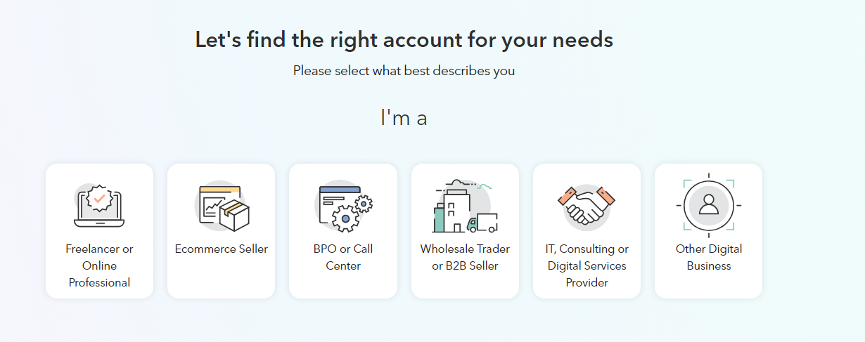
- Step 3: You have to select for what purpose you will use your Payoneer account. You can select “Get paid by international clients or freelance market place”
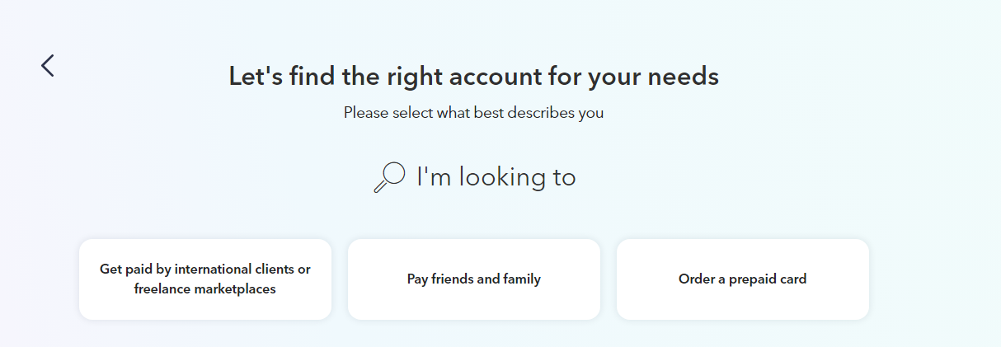
- Step 4: Now you have to select how much money you will going to receive monthly, you can select the relevant option as per your need.
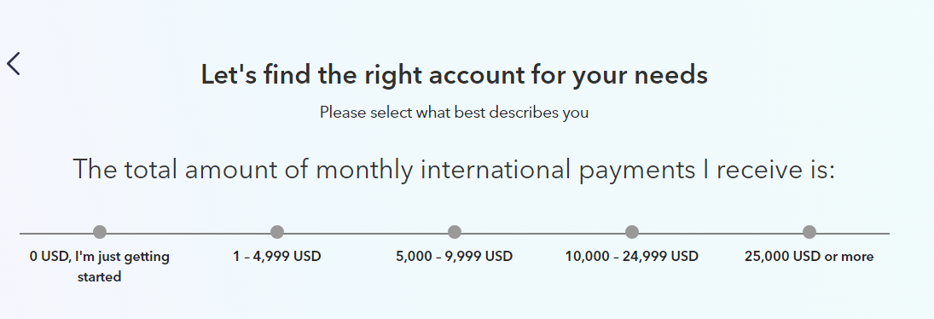
- Step 5: Next step will let you know that what account is right for you and you can then just click on register.
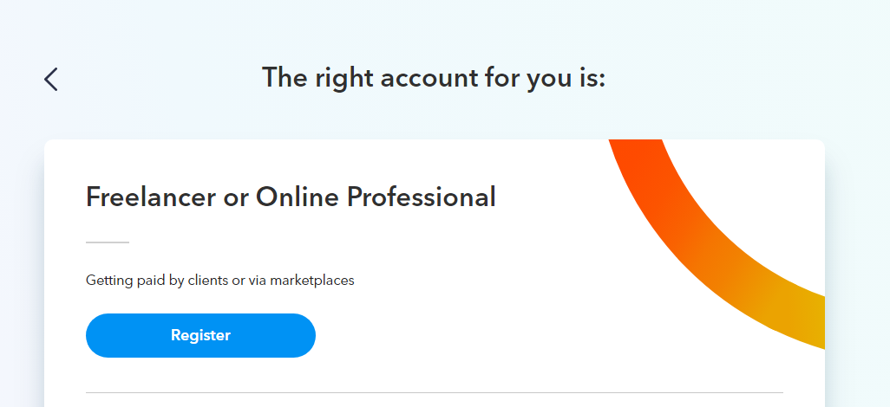
- Step 6: On the next page, they will ask for your information, you can just fill in your personal details on this page. You need to select individual in type of business, else Payoneed will ask you the business details.
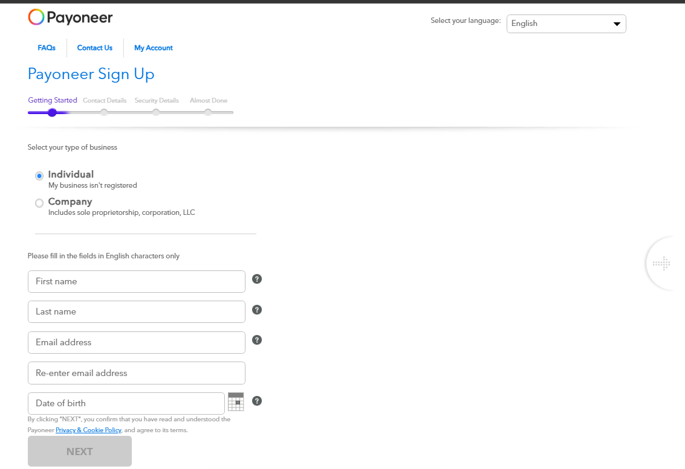
- Step 7: Now fill in your contact details, make sure to use that phone number which is accessible at any point of time. You need to click on send code, and enter the code which will be received by you on your number.
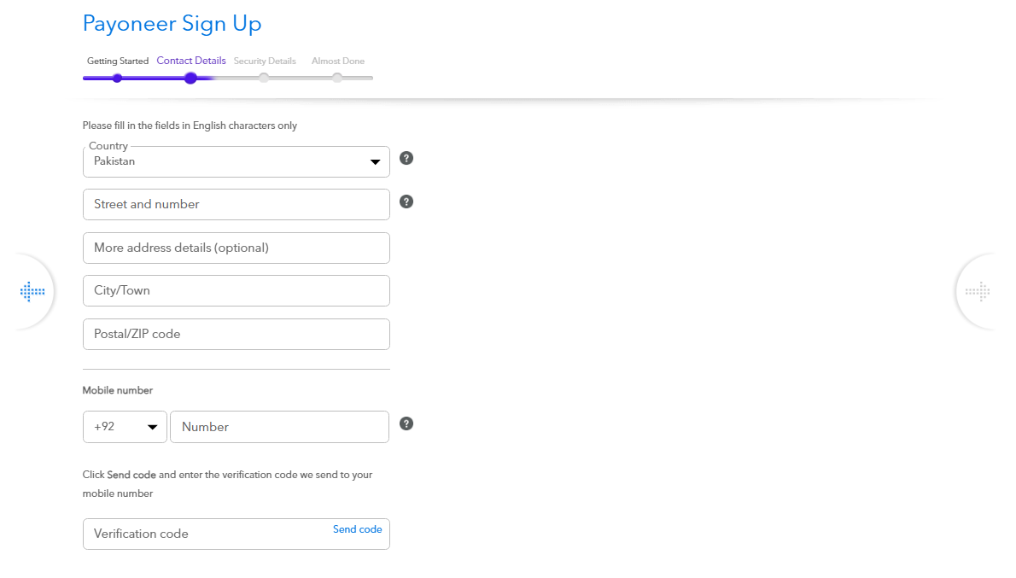.

- Step 8: Now you need to add Security Details, put password, add security question and verification document which could be your Smart Card, Passport, or Driving Licence. Make sure the document should be in English. (Smart Card, Passport)
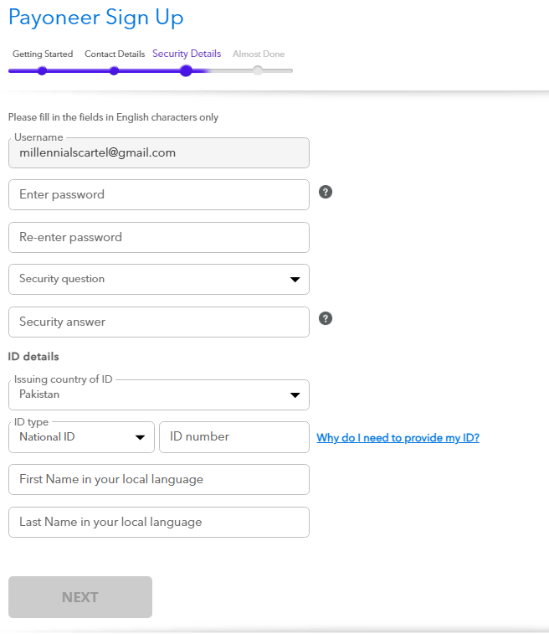
- Step 3: Finally add your Bank details to which you want to transfer your Payoneer amount.
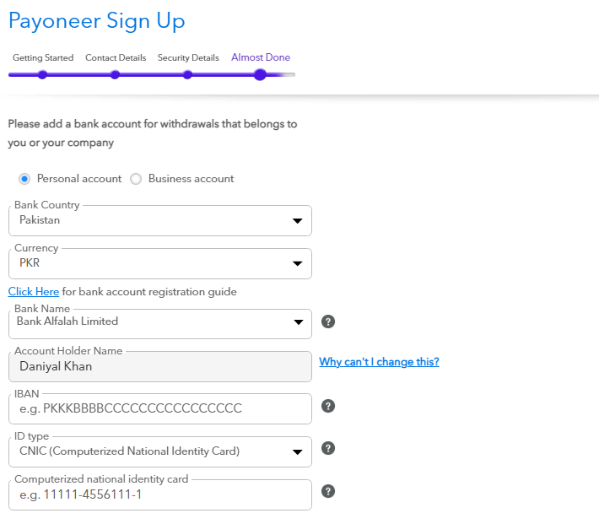
Requesting Payment from Payoneer:
- Step 1: To receive payments you need to click get paid in the left column of your screen.
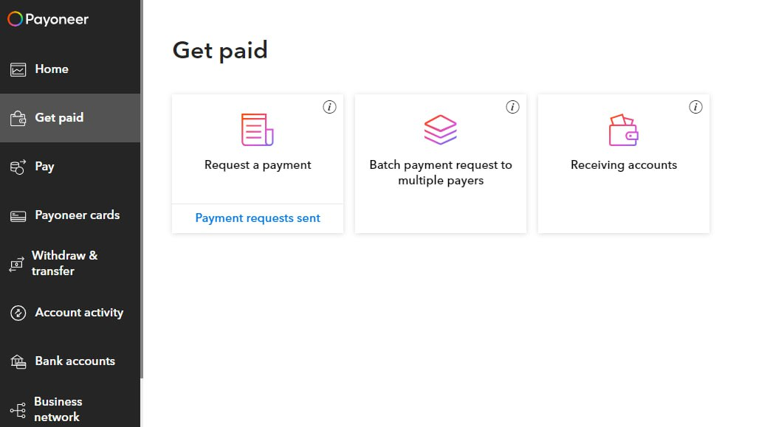

- Step 2: Then click Request a payment.
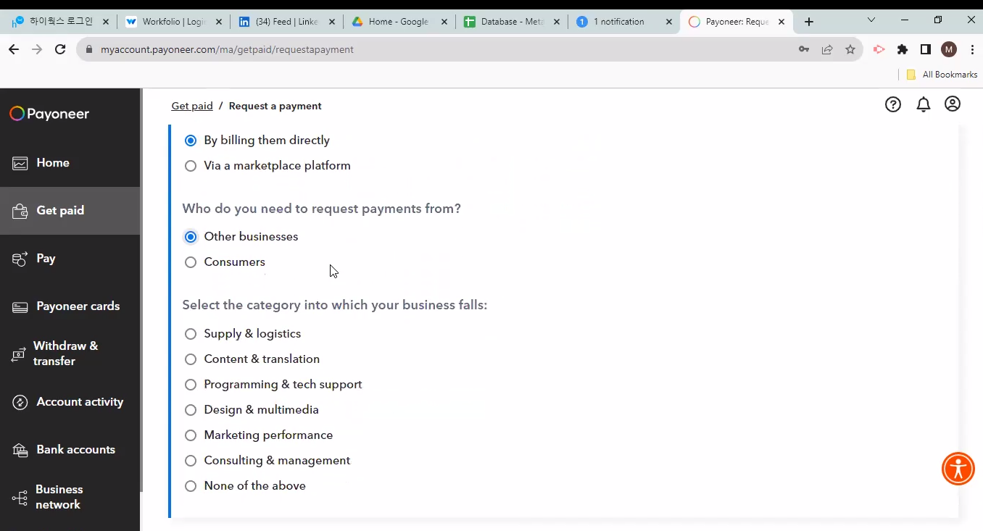

- Step 3: Now check the boxes, in first check “By billing them directly”, in second check “Other business”, and in third choose your relevant department and then click on provide detail button which will pop up after checking the boxes.
- Step 4: After clicking on Provide Details button you will see this page, just click on Submit which will be there.
- Step 5: Now you will another form, you will have to fill in the information.
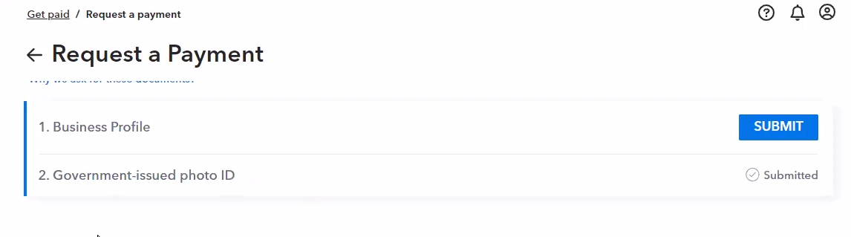1st check the business category, mark same as you marked previously.
2nd. Add services that you provide, in whatever department you are.
3rd in DBA add company name “Imperial Assets”
4th and company company website as well “https://imperialsto.com/”
5th, in “tell us about your business” you can write a brief intro about what our company does. “We provide optimal solutions, executions, and consultation for the entire BLockchain and Web3 technology.”
6th, mark the remaining check boxes. Please refer to the screenshots attached.
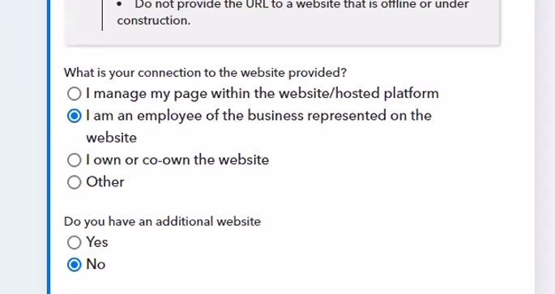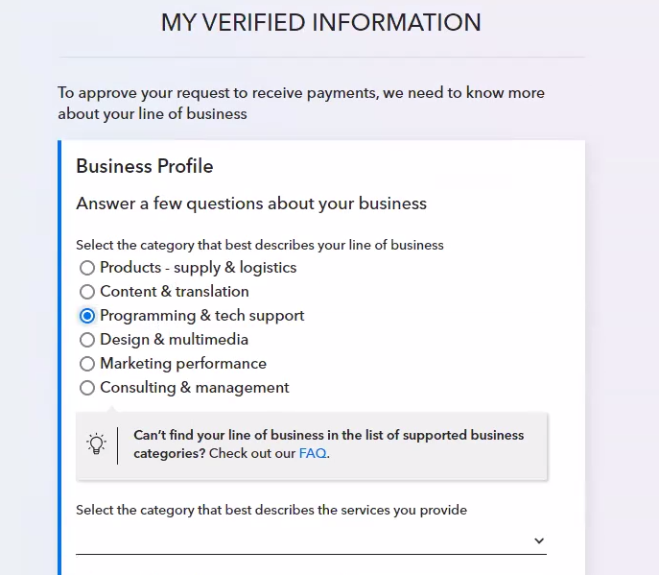

- Step 6: Now you will be able to request the payments and you will be seeing this page below. You need to fill in the details with the information below in Individual Tab.
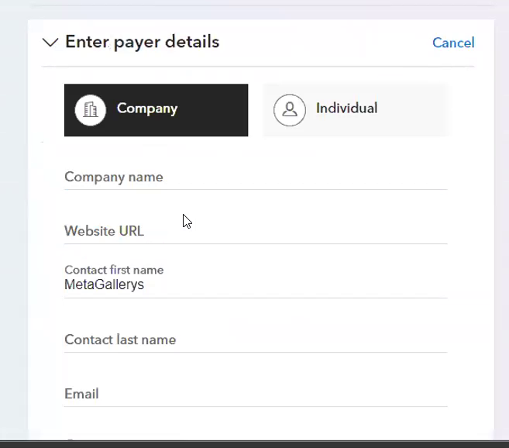
First Name: Seungmin
Second Name: Yeom
Email: yeomsm7@gmail.com
Country: Republic of Korea, South Korea.
After filling in this information, you will proceed to the next steps and add your salary amount which will be shared by you by the HR team, and in attachments you will attach the screenshot of your salary provided by the HR team.
You can ping me, or your manager, or HR team if you face any issue in creating a Payoneer Account or in Requesting the information.
Thank you.

This OJT plan is designed to provide a thorough understanding of how to use Payoneer for financial transactions, specifically focusing on account creation and payment requests. The plan is flexible and can be adjusted based on the specific needs of the participants.

