Accounting team OJT
How to pay for the milestone at UPwork
(Video Explaining) BRICKON Service Development Easy Guideline for development
https://drive.google.com/drive/folders/1ebBe23MZ2rDfxlzREDQdWqtZQv-t5pV-?usp=sharing

1. UXUI
https://www.figma.com/file/L0ovfftdFyKAvoLKclOr32/BRICKON-%26-MC9-%26-Premium-Service-and-all-(OKX-Layer-2-exchange)?type=design&node-id=0%3A1&mode=design&t=lgmE6UJmpNIAJw7t-1

Mobile Responsive verification needed according to video guideline (You can refer to OKX.com. Please check the OKX.com and import or copy that design according to [Web to Figma] Plugin according to video guideline. Or modify as much as we can for mobile responsive)

2.Exchange API
https://www.okx.com/docs-v5/en/

3. Trading view API
https://www.tradingview.com/rest-api-spec/

4.ID, PW for the server
1) AWS ID PW
Account : gbrickWallet (Name is only wallet, it has a exchange Instance. Please set up and build up the source code at this instance server)

[Email ID PW] for
ID gbrickWallet@gmail.com
PW Gbrickwallet##
DOMAIN : gbrickwallet.com

[username ID PW] for Admin
New Credentials for AWS (Brickon Project)
ID: gbrickWallet@gmail.com
PS:Gbrick321##

In this AWS server, they purchased the brickon.io (Duplicate Exchange using Bittok Exchange)

2) [DNS ID,PW] Domain Name Server
www.YESNIC.com (hosting site)
ID : gbrick / PW : Csk3839##

Brickon.io

3.[Dns]
Name Server: dns1.yesnic.com
Name Server: dns2.yesnic.com
Name Server: dns3.yesnic.com
Name Server: dns4.yesnic.com

These Tools will help your work load being less and easier than before.

It's really easy because of these plugins or extension.

[It take 15 mins]
(Publishing normally take 30min -1 hr to do totally)

Canva>Figma>Source code

(30 secs - 1 min)
1. Canva > Figma (Conversion)
https://youtu.be/W1_Xagat5mI?feature=shared

(30 secs - 1 min)
2.Figma > Visual Studio Code (Conversion)
https://youtube.com/shorts/ep59u8q3Hq0?feature=shared

(30 secs to 1 min)
3.Figma > Html Css or React JS, Flutter and etc all
https://youtu.be/zXckEyjM3dg?feature=shared

Materials to let developers team prepare (Design and Explanation or Guide video) with Server info + DNS info

Step 1. Set the Minimum Budget

Strategy of negotiation
(1)Extreme minimum budget + (2) Detail Description
= can make people get persuaded
This week
1.Publishing 1000 (PC, Mobile) > you can use the converter plugin and it might take 30 mins to do all things if we use the figma > web converter plugin

Next week
2. API Integration (Spot, Future,Wallet) 1000 USD
( Let people sign up and deposit the money for the subscription )

3rd week after starting day
3. Finishing with Trading view chart + API integration for calculation function(it's simple) 1000 USD

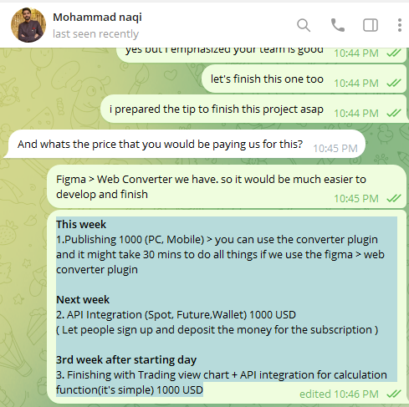

[Figure] PSS when we start the negotiation
Step 2. Negotiation

(If developer rejected minimum price, you can negotiate it)

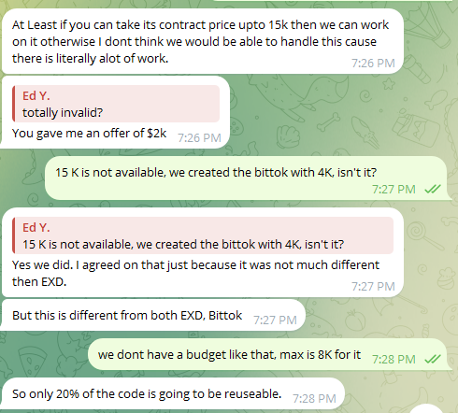 | Even though our company was looking for a cheaper price, there is no more chance to minimize the budget?  You have to start to set the milestone  (1)Extreme minimum budget + (2) Detail Description  = can make people get persuaded  Keep negotiation and let them set visualisation and basic interface should be done earlier in whole milestones
[Developers team reject and keep their price > You can try to D/C but at the end of the point, you should proceed to set the milestone.

Accounting team will always check whether internal Developer or PM who contacted the 3rd party developer tried to D/C according to their conversation before proceeding the payment to check our internal team’s compliance

(Accounting team always should check : This is Accounting team’s task responsibility)

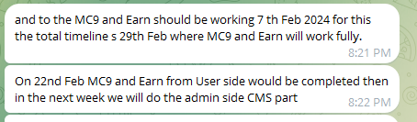
Check the main reasons why it takes long time

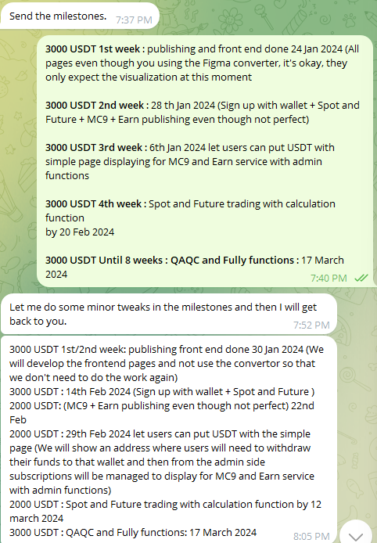
Milestone negotiation

Client (Our company) | Outsourcing developer
3000 USDT 1st week : publishing and front end done 24 Jan 2024 (All pages even though you using the Figma converter, it's okay, they only expect the visualization at this moment  3000 USDT 2nd week : 28 th Jan 2024 (Sign up with wallet + Spot and Future + MC9 + Earn publishing even though not perfect)  3000 USDT 3rd week : 6th Jan 2024 let users can put USDT with simple page displaying for MC9 and Earn service with admin functions  3000 USDT 4th week : Spot and Future trading with calculation function  by 20 Feb 2024  3000 USDT Until 8 weeks : QAQC and Fully functions : 17 March 2024 | 3000 USDT 1st/2nd week: publishing front end done 30 Jan 2024 (We will develop the frontend pages and not use the convertor so that we don't need to do the work again)  3000 USDT : 14th Feb 2024 (Sign up with wallet + Spot and Future )  2000 USDT: (MC9 + Earn publishing even though not perfect) 22nd Feb  2000 USDT : 29th Feb 2024 let users can put USDT with the simple page (We will show an address where users will need to withdraw their funds to that wallet and then from the admin side subscriptions will be managed to display for MC9 and Earn service with admin functions)  2000 USDT : Spot and Future trading with calculation function by 12 march 2024  3000 USDT : QAQC and Fully functions: 17 March 2024

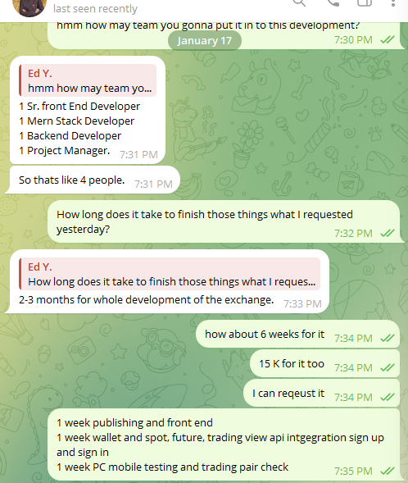 | Additionally  Try to minimize the time to develop specific stuffs.  Time is Commodity, please keep that in mind always.  [Case Study]  Once developers requested 12 weeks, minimize the 6 weeks (50%), and then, finally we got acceptance for 8 weeks  After this, you have to set additionally contract detail to show users to play the service or to see the service earlier.  Let’s take a look at following next Step 3.

Step 3. Set up additional detail milestone per each
(If developer rejected minimum price, you can negotiate it)
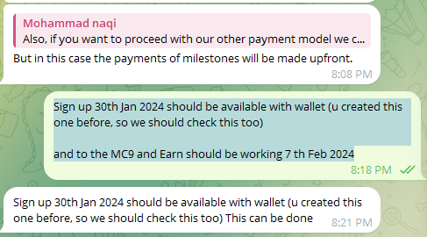
[Core milestone request to outsourcing developer]
Sign up 30th Jan 2024 should be available with wallet (u created this one before, so we should check this too)

and to the MC9 and Earn should be working with Admin (CMS) at 7 th Feb 2024

Manager should set the due time for each milestone according to the client's request. Otherwise, we can not proceed and get the confirmation from the client
Step 4. Set the Milestone and Pay for the 1st escrow

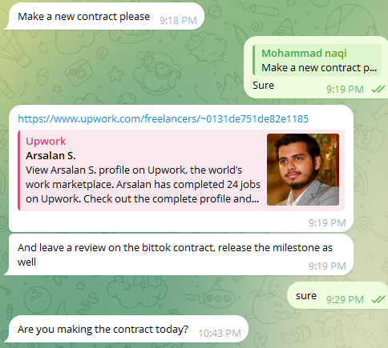
According to our milestone negotiation, Please let team get the escrow payment
Summary Video to set the milestone according to discussion

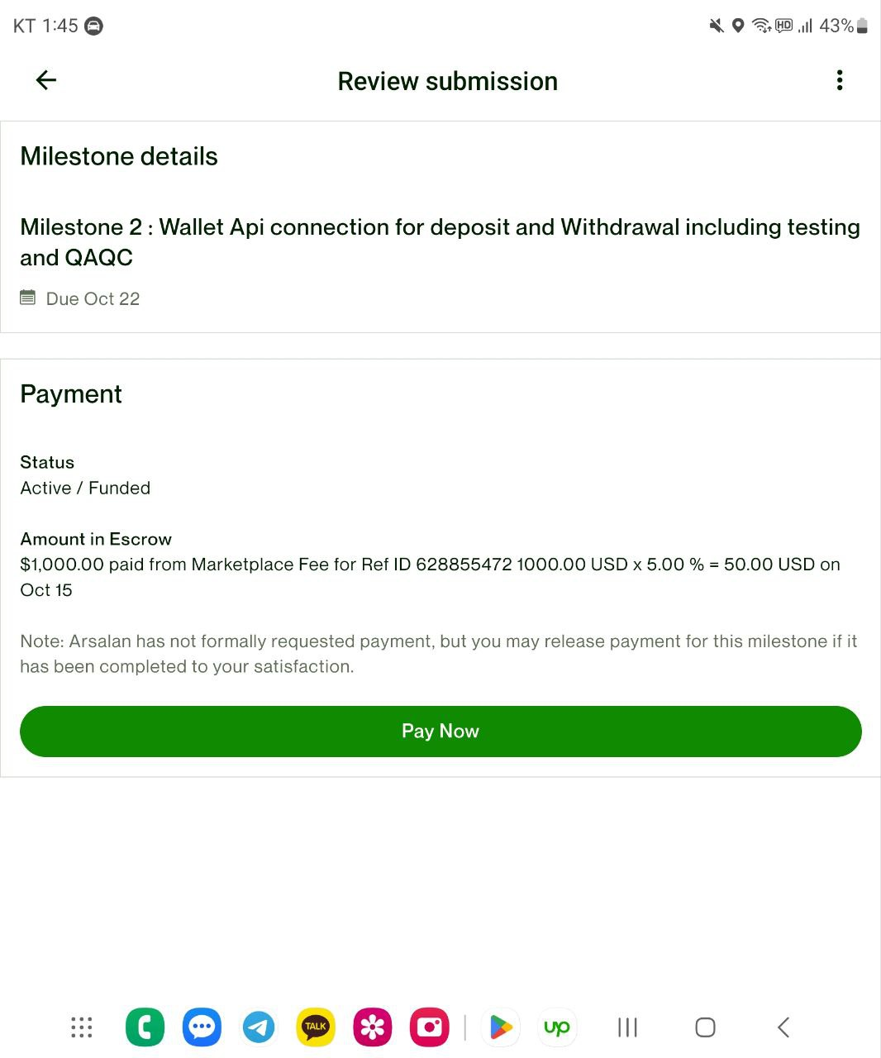 | 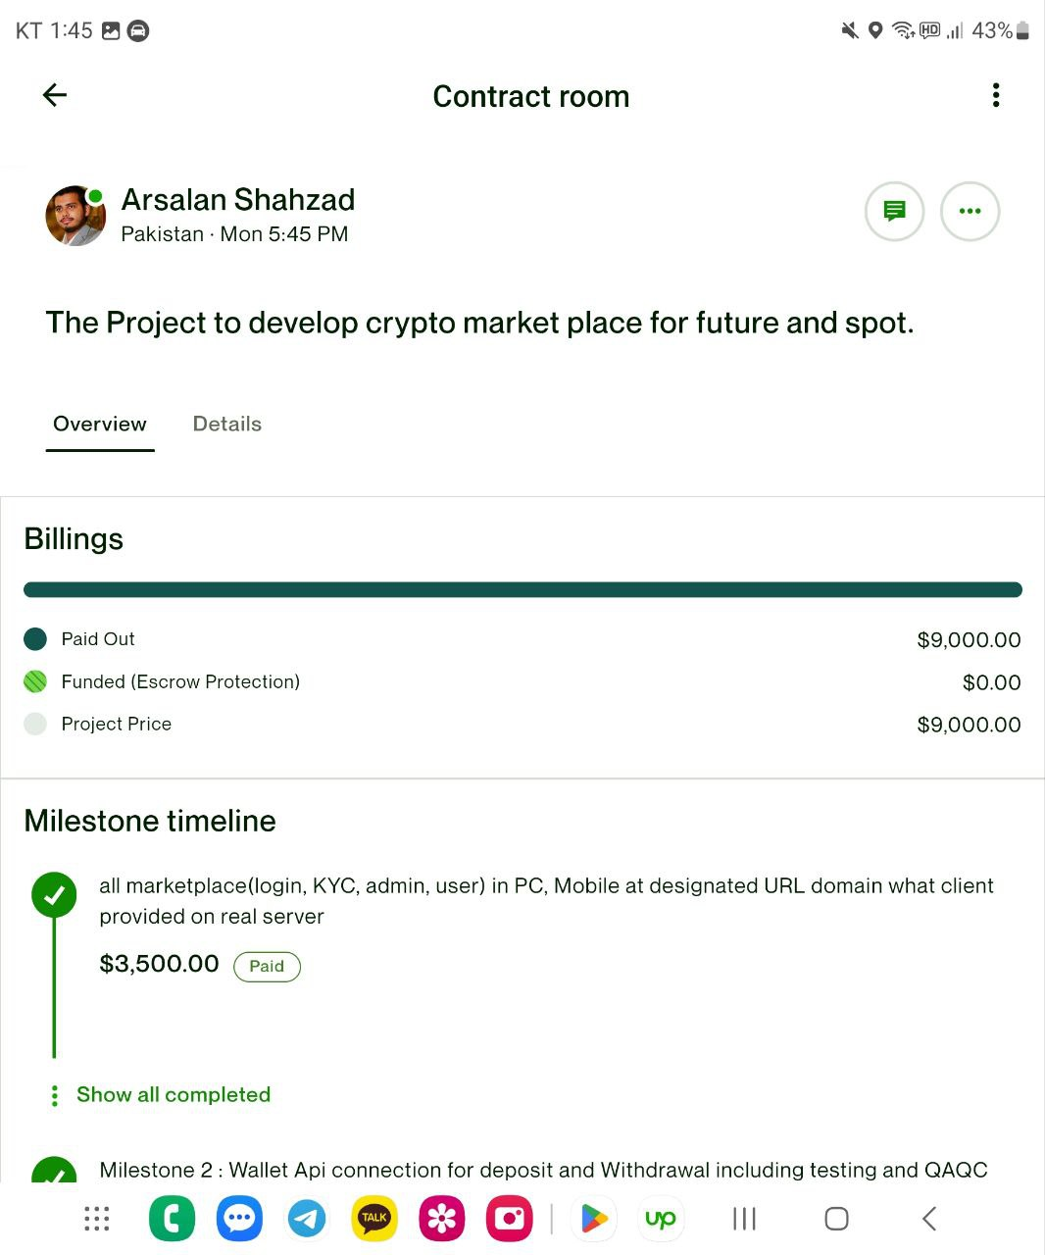
Set the milestone | Check the Escrow

Go to the Upwork.com
Upwork : dev@newmeon.com
PW : Gkffhdnls132@
PW question: favorite sports team : spurs

And pay for it with company credit card

